**PROJECT REPORT**

**ON**

**AUTOMATIC FACE DETECTION AND ATTENDANCE MANAGEMENT**

Project-I



Department of Computer Science and Engineering

**CHANDIGARH ENGINEERING COLLEGE JHANJERI, MOHALI**

**In partial fulfillment of the requirements for the award of the Degree of**

**Bachelor of Technology in Computer Science & Engineering**

**SUBMITTED BY: Under the Guidance of**

Dheeraj Singh (1816539) Dr. Rini Saxena

Vishwajeet Singh (1816882) Professor, CSE Dept.

Ritik Kumar (1816865)

JUNE 2021



**Affiliated to I.K Gujral Punjab Technical University, Jalandhar**

**(Batch: 2018-2022)**

**DECLARATION**

I, Dheeraj Singh, Vishwajeet Singh, Ritik Kumar hereby declare that the report of the project entitled “Automatic Face Detection and Attendance Management” has not presented as a part of any other academic work to get my degree or certificate except Chandigarh Engineering College Jhanjeri, Mohali, affiliated to I.K. Gujral Punjab Technical University, Jalandhar, for the fulfillment of the requirements for the degree of B.Tech in Computer Science & Engineering.

(Student Signature with Date)

**Dheeraj Singh**

Univ. Roll No: 1816539

**Vishwajeet Singh**

Univ. Roll No: 1816882

**Ritik Kumar**

Univ. Roll No: 1816865

Semester: 6th

**ACKNOWLEDGEMENT**

It is great pleasure to present this report on the **project title** “Automatic Face Detection and Attendance Management” undertaken by me as part of my B.Tech degree in Computer Science & Engineering final year. I am thankful to my university for offering me such a wonderful challenging opportunity and I express my deepest thanks to all coordinators, for providing all the possible help and assistance and their constant encouragements.

I am extremely thankful to **Dr. Anil Kumar Lamba,** HOD, Computer Science & Engineering, Chandigarh Engineering College Jhanjeri, Mohali (Punjab) for valuable suggestions and motivation.

I am also thankful to all my teachers who have taught me till date in my degree, management of institute and Dr. Rajneesh Talwar, Director Engineering for providing me the opportunity to get the knowledge.

(Signature of Student)

**Dheeraj Singh(1816539)**

**Vishwajeet Singh(1816882)**

**Ritik Kumar(1816865**)

**TABLE OF CONTENTS**

|  |  |  |  |  |  |
| --- | --- | --- | --- | --- | --- |
| **PARTICULARS** | | | | | **PAGE NO** |
| Title Page | | | | | I |
| Declaration by the Candidate | | | | | II |
| Acknowledgement | | | | | III |
| Table of Contents | | | | | IV  V |
| Abstract | | | | | VI |
| List of Tables | | | | | VII |
| List of Figures | | | | |  |
| **CHAPTER 1 INTRODUCTION** | | | | | **10** |
| 1.1 | | Background | | |  |
| 1.2 | | Problem Statement | | |  |
| **CHAPTER 2 REVIEW OF LITERATURE** | | | | | 14 |
| 2.1 | | Student Attendance System | | |  |
| 2.2 | | Face Detection | | |  |
|  | | 2.2.1 | Viola-Jones Algorithm (Haar Cascade) | |  |
| 2.3 | | Pre-Processing | | |  |
| 2.4 | | Feature Extraction | | |  |
| **CHAPTER 3 PROBLEM DEFINITION AND OBJECTIVES** | | | | | **23** |
| 3.1 | Objective | | | |  |
| **CHAPTER 4 DESIGN AND IMPLEMENTATION** | | | | | **24** |
| 4.1 | | System Requirement | | |  |
| 4.2 | | Methodology Flow | | |  |
| 4.3 | | Input Image | | |  |
|  | | 4.3.1 | | Limitations of the Images |  |
| 4.4 | | Face Detection | | |  |
|  | | 4.4.1 | | Pre-processing |  |
|  | | 4.4.2 | | Scaling of Images |  |
|  | | 4.4.3 | | Media Filtering |  |
|  | | 4.4.4 | | Conversion to Grayscale Image |  |
| 4.5 | | Feature Extraction | | |  |
| 4.6 | | System Design | | |  |
| 4.7 | | Software Design | | |  |
| 4.8 | | Experimental Design | | |  |
| 4.9 | | Implementation | | |  |
| **CHAPTER 5 RESULTS AND DISCUSSIONS** | | | | | **34** |
| 5.1 | | Result | | |  |
| 5.2 | | Conclusion | | |  |
| 5.3 | | Weakness of Algorithm | | |  |
| 5.5 | | Recommendations | | |  |
| **CHAPTER 6 CONCLUSION AND FUTURE SCOPE** | | | | | **40** |
| 6.1 | | Conclusion | | |  |
| 6.2 | | Future Scope | | |  |
| **REFERENCES** | | | | |  |
| **PUBLICATIONS** | | | | |  |

**ABSTRACT**

Automatic Face Detection and Attendance Management System deal with the maintenance of the student’s attendance details by solving the issues of existing manual systems It generates the attendance of the student on basis of presence in class. It maintains the record on daily basis of attendance, the individuals are provided with the separate username and password to mark the attendance. The student who is not registered will also be able to register on the spot and notification will be given if students sign in more than once. The average accuracy of recognition is 100 % for good quality images, 94.12 % of low-quality images and 95.76 % for Yale face database when two images per person are trained.

Only if the student presents the particular date, the attendance will be calculated. The student attendance report based on monthly and consolidate will be generated. The system performs satisfactory in different poses and variations, also we have some processing limitation, working with a system of high processing may result even better performance of this system.

**LIST OF TABLES**

|  |  |  |
| --- | --- | --- |
| **TABLES** | **TITLES** | **PAGE NO** |
| 2.1 | Advantages & Disadvantages of Different Biometric System |  |
| 2.2 | Factors Causing Face Detection Difficulties |  |
| 2.3 | Advantages & Disadvantages of Face Detection Methods |  |

**LIST OF FIGURES**

|  |  |  |
| --- | --- | --- |
| **TABLES** | **TITLES** | **PAGE NO** |
| 2.1 | A sample of Haar features used in the Original Research Paper published by Viola and Jones. |  |
| 2.2 | The rectangle on the left is a sample representation of an image with pixel values 0.0 to 1.0. The rectangle at the center is a haar kernel which has all the light pixels on the left and all the dark pixels on the right. The haar calculation is done by finding out the **difference** of the **average of the pixel values at the darker region** and the **average of the pixel values at the lighter region**. If the difference is close to 1, then there is an edge detected by the haar feature. |  |
| 2.3 | The GIF shows how a haar feature traverses on an image from its left towards its right. |  |
| 2.4 | The GIF shows the making of an Integral Image. Each pixel in an Integral image is the sum of all the pixels in its left and above. |  |
| 4.1 | Flow of the Proposed Approach (Training Part) |  |
| 4.2 | Flow of the Proposed Approach (Recognition Part) |  |
| 4.3 | Sample Images in Yale Face Database (Cvc.cs.yale.edu, 1997) |  |
| 4.4 | Sample of High Quality Images |  |
| 4.5 | 5 Sample of Low Quality Images |  |
| 4.6 | Median Filtering Done on Three Channel |  |
| 5.1 | Processing image and matching with the provided dataset |  |
| 5.2 | A web cam pop up when the program is run on server to detect the face in front of it and match it with the saved data set and mark the attendance of the person. |  |
| 5.3 | The front end of the server program |  |
| 5.4 | Attendance in Excel File with name and time |  |

Chapter-1

**INTRODUCTION**

Every organization requires a robust and stable system to record the attendance of their students. and every organization have their own method to do so, some are taking attendance manually with a sheet of paper by calling their names during lecture hours and some have adopted biometrics system such as fingerprint, RFID card reader, Iris system to mark the attendance. The conventional method of calling the names of students manually is time consuming event. The RFID card system, each student assigns a card with their corresponding identity but there is chance of card loss or unauthorized person may misuse the card for fake attendance. While in other biometrics such as finger print, iris or voice recognition, they all have their own flaws and also they are not 100% accurate.

Use of face recognition for the purpose of attendance marking is the smart way of attendance management system. Face recognition is more accurate and faster technique among other techniques and reduces chance of proxy attendance. Face recognition provide passive identification that is a person which is to be identified does not to need to take any action for its identity.

Face recognition involves two steps, first step involves the detection of faces and second step consist of identification of those detected face images with the existing database. There are number of face detection and recognition methods introduced. Face recognition works either in form of appearance based which covers the features of whole face or feature based which covers the geometric feature like eyes, nose, eye brows, and cheeks to recognize the face Our system uses face recognition approach to reduce the flaws of existing system with the help of machine learning, it requires a good quality camera to capture the images of students, the detection process is done by histogram of oriented gradient. And recognizing perform through deep learning. The frontend side (client side) which consist of GUI which is based on electron JS and backend side consist of logic and python (server side), an IPC (Inter Personal Communication) bridge is developed to communicate these two stacks. The images capture by the camera is sent to system for further analysis, the input image is then compared with a set of reference images each of the student and mark their attendance.

**1.1 Background**

Face recognition is crucial in daily life in order to identify family, friends or someone we are familiar with. We might not perceive that several steps have actually taken in order to identify human faces. Human intelligence allows us to receive information and interpret the information in the recognition process. We receive information through the image projected into our eyes, by specifically retina in the form of light. Light is a form of electromagnetic waves which are radiated from a source onto an object and projected to human vision. Robinson-Riegler, G., & Robinson-Riegler, B. (2008) mentioned that after visual processing done by the human visual system, we actually classify shape, size, contour and the texture of the object in order to analyse the information. The analysed information will be compared to other representations of objects or face that exist in our memory to recognize. In fact, it is a hard challenge to build an automated system to have the same capability as a human to recognize faces. However, we need large memory to recognize different faces, for example, in the Universities, there are a lot of students with different race and gender, it is impossible to remember every face of the individual without making mistakes. In order to overcome human limitations, computers with almost limitless memory, high processing speed and power are used in face recognition systems.

The human face is a unique representation of individual identity. Thus, face recognition is defined as a biometric method in which identification of an individual is performed by comparing real-time capture image with stored images in the database of that person (Margaret Rouse, 2012).

The work on face recognition began in 1960. Woody Bledsoe, Helen Chan Wolf and Charles Bisson had introduced a system which required the administrator to locate eyes, ears, nose and mouth from images. The distance and ratios between the located features and the common reference points are then calculated and compared. The studies are further enhanced by Goldstein, Harmon, and Lesk in 1970 by using other features such as hair colour and lip thickness to automate the recognition. In 1988, Kirby and Sirovich first suggested principle component analysis (PCA) to solve face recognition problem. Many studies on face recognition were then conducted continuously until today (Ashley DuVal, 2012).

**1.2 Problem Statement**

Traditional student attendance marking technique is often facing a lot of trouble. The face recognition student attendance system emphasizes its simplicity by eliminating classical student attendance marking technique such as calling student names or checking respective identification cards. There are not only disturbing the teaching process but also causes distraction for students during exam sessions. Apart from calling names, attendance sheet is passed around the classroom during the lecture sessions. The lecture class especially the class with a large number of students might find it difficult to have the attendance sheet being passed around the class. Thus, face recognition student attendance system is proposed in order to replace the manual signing of the presence of students which are burdensome and causes students get distracted in order to sign for their attendance. Furthermore, the face recognition based automated student attendance system able to overcome the problem of fraudulent approach and lecturers does not have to count the number of students several times to ensure the presence of the students.

Hence, there is a need to develop a real time operating student attendance system which means the identification process must be done within defined time constraints to prevent omission. The extracted features from facial images which represent the identity of the students have to be consistent towards a change in background, illumination, pose and expression. High accuracy and fast computation time will be the evaluation points of the performance.

Chapter- 2

**REVIEW OF LITERATURE**

**2.1 Student Attendance System**

Arun Katara et al. (2017) mentioned disadvantages of RFID (Radio Frequency Identification) card system, fingerprint system and iris recognition system. RFID card system is implemented due to its simplicity. However, the user tends to help their friends to check in as long as they have their friend’s ID card. The fingerprint system is indeed effective but not efficient because it takes time for the verification process so the user has to line up and perform the verification one by one. However for face recognition, the human face is always exposed and contain less information compared to iris. Iris recognition system which contains more detail might invade the privacy of the user. Voice recognition is available, but it is less accurate compared to other methods. Hence, face recognition system is suggested to be implemented in the student attendance system.

**Table 2.1** **Advantages & Disadvantages of Different Biometric System**

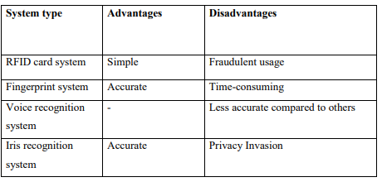

**2.2 Face Detection**

Difference between face detection and face recognition are often misunderstood. Face detection is to determine only the face segment or face region from image, whereas face recognition is to identify the owner of the facial image. There are few factors which cause face detection and face recognition to encounter difficulties. These factors consist of background, illumination, pose, expression, occlusion, rotation, scaling and translation. The definition of each factor is tabulated in the given below Table.

**Table 2.2 Factors Causing Face Detection Difficulties**

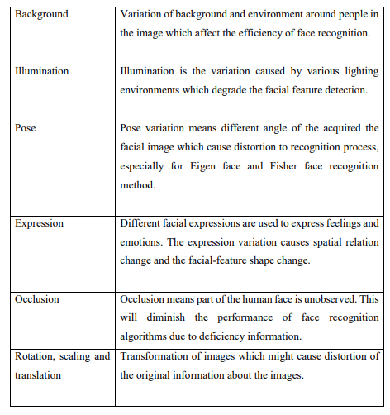

There are a few face detection methods that the previous researchers have worked on. However, most of them used frontal upright facial images which consist of only one face. The face region is fully exposed without obstacles and free from the spectacles.

**Table 2.3 Advantages & Disadvantages of Face Detection Methods**

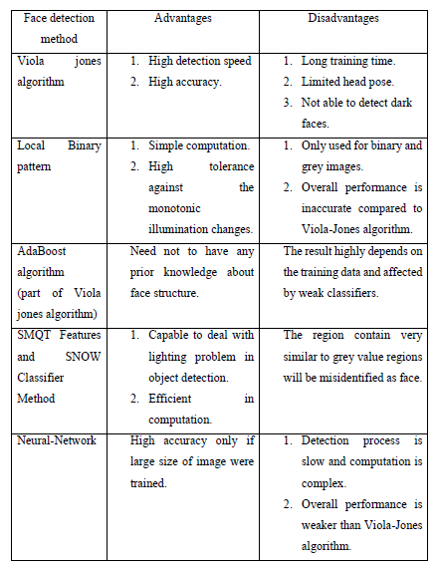

**2.2.1 Viola-Jones Algorithm (Haar Cascade)**

It is an Object Detection Algorithm used to identify faces in an image or a real time video. The algorithm uses edge or line detection features proposed by Viola and Jones in their research paper “Rapid Object Detection using a Boosted Cascade of Simple Features” published in 2001. The algorithm is given a lot of positive images consisting of faces, and a lot of negative images not consisting of any face to train on them. The repository has the models stored in XML files, and can be read with the OpenCV methods. These include models for face detection, eye detection, upper body and lower body detection, license plate detection etc. Below we see some of the concepts proposed by Viola and Jones in their research.

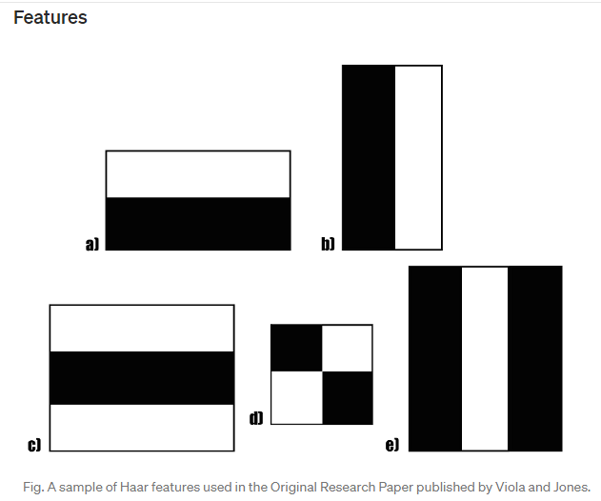

**Fig 2.1** A sample of Haar features used in the Original Research Paper published by Viola and Jones.

The first contribution to the research was the introduction of the haar features shown above. These features on the image makes it easy to find out the edges or the lines in the image, or to pick areas where there is a sudden change in the intensities of the pixels.

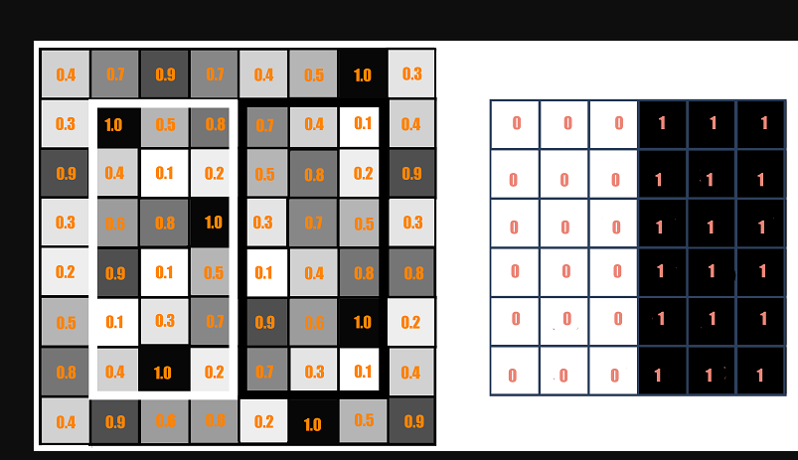



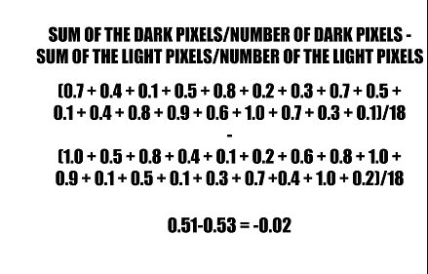

**Fig 2.2** The rectangle on the left is a sample representation of an image with pixel values 0.0 to 1.0. The rectangle at the center is a haar kernel which has all the light pixels on the left and all the dark pixels on the right. The haar calculation is done by finding out the **difference** of the **average of the pixel values at the darker region** and the **average of the pixel values at the lighter region**. If the difference is close to 1, then there is an edge detected by the haar feature.

A sample calculation of Haar value from a rectangular image section has been shown here. The darker areas in the haar feature are pixels with values 1, and the lighter areas are pixels with values 0. Each of these is responsible for finding out one particular feature in the image. Such as an edge, a line or any structure in the image where there is a sudden change of intensities. For ex. in the image above, the haar feature can detect a vertical edge with darker pixels at its right and lighter pixels at its left.

The objective here is to find out the sum of all the image pixels lying in the darker area of the haar feature and the sum of all the image pixels lying in the lighter area of the haar feature. And then find out their difference. Now if the image has an edge separating dark pixels on the right and light pixels on the left, then the haar value will be closer to 1. That means, we say that there is an edge detected if the haar value is closer to 1. In the example above, there is no edge as the haar value is far from 1.

This is just one representation of a particular haar feature separating a vertical edge. Now there are other haar features as well, which will detect edges in other directions and any other image structures. To detect an edge anywhere in the image, the haar feature needs to traverse the whole image.



**Fig 2.3.** The GIF shows how a haar feature traverses on an image from its left towards its right.

The haar feature continuously traverses from the top left of the image to the bottom right to search for the particular feature. This is just a representation of the whole concept of the haar feature traversal. In its actual work, the haar feature would traverse pixel by pixel in the image. Also all possible sizes of the haar features will be applied.

Depending on the feature each one is looking for, these are broadly classified into three categories. The first set of two rectangle features are responsible for finding out the edges in a horizontal or in a vertical direction (as shown above). The second set of three rectangle features are responsible for finding out if there is a lighter region surrounded by darker regions on either side or vice-versa. The third set of four rectangle features are responsible for finding out change of pixel intensities across diagonals.

Now, the haar features traversal on an image would involve a lot of mathematical calculations. As we can see for a single rectangle on either side, it involves 18 pixel value additions (for a rectangle enclosing 18 pixels). Imagine doing this for the whole image with all sizes of the haar features. This would be a hectic operation even for a high performance machine.



**Fig 2.4** The GIF shows the making of an Integral Image. Each pixel in an Integral image is the sum of all the pixels in its left and above.

**2.3 Pre-Processing**

Pre-processing enhances the performance of the system. It plays an essential role to improve the accuracy of face recognition. Scaling is one of the important preprocessing steps to manipulate the size of the image. Scaling down of an image increases the processing speed by reducing the system computations since the number of pixels are reduced. The size and pixels of the image carry spatial information. Gonzalez, R. C. and Woods (2008) mentioned spatial information is a measure of the smallest discernible detail in an image. Hence, spatial information has to be manipulated carefully to avoid distortion of images to prevent checkerboard effect. The size should be same for all the images for normalization and standardization purposes. Subhi Singh et al (2015) proposed PCA (Principal Component Analysis) to extract features from facial images, same length and width of image is preferred, thus images were scaled to 120 × 120 pixels.

Besides scaling of images, colour image is usually converted to grayscale image for pre-processing. Grayscale images are believed to be less sensitive to illumination condition and take less computational time. Grayscale image is 8 bit image which the pixel range from 0 to 255 whereas colour image is 24 bit image which pixel can have 16 77 7216 values. Hence, colour image requires more storage space and more computational power compared to grayscale images. (Kanan and Cottrell, 2012). If colour image is not necessary in computation, then it is considered as noise. In addition, pre-processing is important to enhance the contrast of images. In the paper of Pratiksha M. Patel (2016), he mentioned that Histogram equalization is one of the methods of pre-processing in order to improve the contrast of the image. It provides uniform distribution of intensities over the intensity level axis, which is able to reduce uneven illumination effect at the same time.

**2.4 Feature Extraction**

The feature is a set of data that represents the information in an image. Extraction of facial feature is most essential for face recognition. However, selection of features could be an arduous task. Feature extraction algorithm has to be consistent and stable over a variety of changes in order to give high accuracy result.

PCA is famous with its robust and high speed computation. Basically, PCA retains data variation and remove unnecessary existing correlations among the original features. PCA is basically a dimension reduction algorithm. It compresses each facial image which is represented by the matrix into single column vector. Furthermore, PCA removes average value from image to centralize the image data. The Principle Component of distribution of facial images is known as Eigen faces. Every single facial image from training set contributes to Eigen faces. As a result, Eigen face encodes best variation among known facial images. Training images and test images are then projected onto Eigen face space to obtain projected training images and projected test image respectively. Euclidean distance is computed by comparing the distance between projected training images and projected test image to perform the recognition. PCA feature extraction process includes all trained facial images. Hence, the extracted feature contains correlation between facial images in the training set and the result of recognition of PCA highly depends on training set image.

Chapter- 3

**PROBLEM DEFINITION AND OBJECTIVES**

**3.1 Objective**

The objective of this project is to develop face recognition based automated student attendance system. Expected achievements in order to fulfill the objectives are:

* To detect the face segment from the video frame.
* To extract the useful features from the face detected.
* To classify the features in order to recognize the face detected.
* To record the attendance of the identified student. To incorporate the server software within the code.
* To use the technologies and Server technology used in here to create strong and secured database connectivity.
* To discover, verify and test new and important facts
* To analyze an event or process or phenomenon to identify the cause and effect relationship
* To develop new scientific tools, concepts and theories to understand scientific and non- scientific problems
* To find solutions to scientific, non-scientific and social problems.

Face recognition provide passive identification that is a person which is to be identified does not to need to take any action for its identity.

Chapter-4

**DESIGN AND IMPLEMENTATION**

4.1 **System Requirement**

As one of the most successful applications of image analysis and understanding, face recognition has recently received signiﬁcant attention, especially during the past several years. At least two reasons account for this trend: the ﬁrst is the wide range of commercial and law enforcement applications, and the second is the availability of feasible technologies after 30 years of research. Even though current machine recognition systems have reached a certain level of maturity, their success is limited by the conditions imposed by many real applications. For example, recognition of face images acquired in an outdoor environment with changes in illumination and/or pose remains a largely unsolved problem. In other words, current systems are still far away from the capability of the human perception system. This paper provides an up-to-date critical survey of still- and video-based face recognition research. There are two underlying motivations for us to write this survey paper: the ﬁrst is to provide an up-to-date review of the existing literature, and the second is to offer some insights into the studies of machine recognition of faces. To provide a comprehensive survey, we not only categorize existing recognition techniques but also present detailed descriptions of representative methods within each category. In addition, relevant topics such as psychophysical studies, system evaluation, and issues of illumination and pose variation are covered.

**4.2 Methodology Flow**

Attendance is an important part of daily classroom evaluation. At the beginning and ending of class, it is usually checked by the teacher, but it may appear that a teacher may miss someone or some students answer multiple times. Face recognition-based attendance system is a problem of recognizing face for taking attendance by using face recognition technology based on high-definition monitor video and other information technology. The concept of face recognition is to give a computer system the ability of finding and recognizing human faces fast and precisely in images or videos. Numerous algorithms and techniques have been developed for improving the performance of face recognition. Recently Deep learning has been highly explored for computer vision applications. Human brain can automatically and instantly detect and recognize multiple faces. But when it comes to computer, it is very difficult to do all the challenging tasks on the level of human brain. The face recognition is an integral part of biometrics. In biometrics, basic traits of human are matched to the existing data. Facial features are extracted and implemented through algorithms, which are efficient and some modifications are done to improve the existing algorithm models. Computers that detect and recognize faces could be applied to a wide variety of practical applications including criminal identification, security systems, identity verification etc. The face recognition system generally involves two stages:

•**Face Detection** – where the input image is searched to find any face, then image processing cleans up the facial image for easier recognition.

•**Face Recognition** – where the detected and processed face is compared to the database of known faces to decide who that person is.

The approach performs face recognition based student attendance system. The methodology flow begins with the capture of image by using simple and handy interface, followed by pre-processing of the captured facial images, then feature extraction from the facial images, subjective selection and lastly classification of the facial images to be recognized. Both LBP and PCA feature extraction methods are studied in detail and computed in this proposed approach in order to make comparisons. LBP is enhanced in this approach to reduce the illumination effect. An algorithm to combine enhanced LBP and PCA is also designed for subjective selection in order to increase the accuracy. The details of each stage will be discussed in the following sections.

The flow chart for the proposed system is categorized into two parts, first training of images followed by testing images (recognize the unknown input image) shown in Figure 4.1 and Figure 4.2 respectively

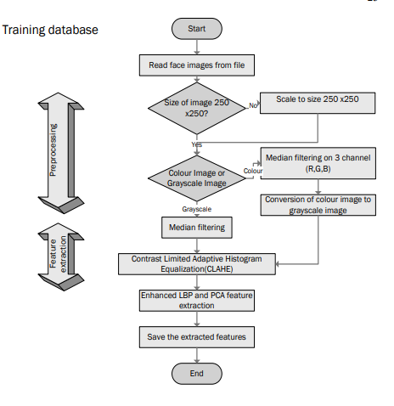

Figure 4.1 Flow of the Proposed Approach (Training Part)

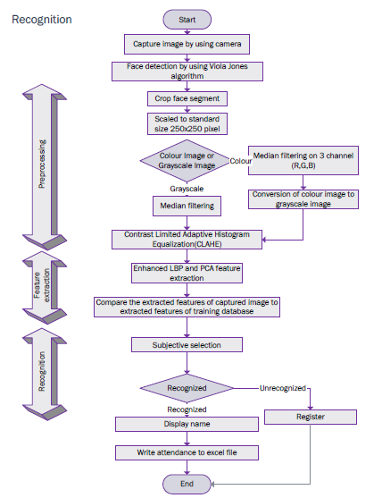

Figure 4.2 Flow of the Proposed Approach (Recognition Part)

**4.3 Input Images**

Although our own database should be used to design real time face recognition student attendance system, the databases that are provided by the previous researchers are also used to design the system more effectively, efficiently and for evaluation purposes. Yale face database is used as both training set and testing set to evaluate the performance. Yale face database contains one hundred and sixty-five grayscale images of fifteen individuals. There are eleven images per individual; each image of the individual is in different condition. The conditions included centre-light, with glasses, happy, left-light, without glasses, normal, right-light, sad, sleepy, surprised and wink. These different variations provided by the database is able to ensure the system to be operated consistently in variety of situations and conditions.

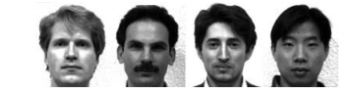

Figure 4.3 Sample Images in Yale Face Database (Cvc.cs.yale.edu, 1997)

For our own database, the images of students are captured by using laptop built in camera and mobile phone camera. Each student provided four images, two for training set and two for testing set. The images captured by using laptop built in camera are categorized as low quality images, whereas mobile phone camera captured images are categorized as high quality images. The high quality images consists of seventeen students while low quality images consists of twenty-six students. The recognition rate of low quality images and high quality images will be compared in Chapter 4 to draw a conclusion in term of performance between image sets of different quality.

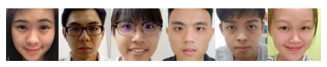

Figure 4.4 Sample of High Quality Images

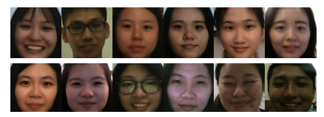

Figure 4.5 Sample of Low Quality Images

**4.3.1 Limitations of the Images**

The input image for the proposed approach has to be frontal, upright and only a single face. Although the system is designed to be able to recognize the student with glasses and without glasses, student should provide both facial images with and without glasses to be trained to increase the accuracy to be recognized without glasses. The training image and testing image should be captured by using the same device to avoid quality difference. The students have to register in order to be recognized. The enrolment can be done on the spot through the user-friendly interface. These conditions have to be satisfied to ensure that the proposed approach can perform well.

**4.4 Face Detection**

Viola-Jones object detection framework will be used to detect the face from the video camera recording frame. The working principle of Viola-Jones algorithm is mentioned in Chapter 2. The limitation of the Viola-Jones framework is that the facial image has to be a frontal upright image, the face of the individual must point towards the camera in a video frame.

**4.4.1 Pre-Processing**

Testing set and training set images are captured using a camera. There are unwanted noise and uneven lighting exists in the images. Therefore, several pre-processing steps are necessary before proceeding to feature extraction. Pre-processing steps that would be carried out include scaling of image, median filtering, conversion of colour images to grayscale images and adaptive histogram equalization. The details of these steps would be discussed in the later sections.

**4.4.2 Scaling of images**

It is one of the frequent tasks in image processing. The size of the images has to be carefully manipulated to prevent loss of spatial information. (Gonzalez, R. C., & Woods, 2008), In order to perform face recognition, the size of the image has to be equalized. This has become crucial, especially in the feature extraction process, the test images and training images have to be in the same size and dimension to ensure the precise outcome. Thus, in this proposed approach test images and train images are standardize at size 250 × 250 pixels.

**4.4.3 Media Filtering**

Median filtering is a robust noise reduction method. It is widely used in various applications due to its capability to remove unwanted noise as well as retaining useful detail in images. Since the colour images captured by using a camera are RGB images, median filtering is done on three different channels of the image. Figure 3.3 shows the image before and after noise removal by median filtering in three channels. If the input image is a grayscale image, then the median filtering can be performed directly without separating the channels.

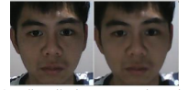

Fig 4.6 Median Filtering Done on Three Channel

**4.4.4 Conversion to Grayscale Image**

Camera captures color images, however the proposed contrast improvement method CLAHE can only be performed on grayscale images. After improving the contrast, the illumination effect of the images able to be reduced. LBP extracts the grayscale features from the contrast improved images as 8 bit texture descriptor (Ojala, T. et al., 2002).Therefore, color images have to be converted to grayscale images before proceeding to the later steps. By converting color images to grayscale images, the complexity of the computation can be reduced resulting in higher speed of computation (Kanan and Cottrell, 2012). Figure 3.4 shows the conversion of images to grayscale image.

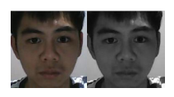

Conversion of Image to Grayscale Image

**4.5 Feature Extraction**

Different facial images mean there are changes in textural or geometric information. In order to perform face recognition, these features have to be extracted from the facial images and classified appropriately. In this project, enhanced LBP and PCA are used for face recognition. The idea comes from nature of human visual perception which performs face recognition depending on the local statistic and global statistic features. Enhanced LBP extracts the local grayscale features by performing feature extraction on a small region throughout the entire image. On the other hand, PCA extracts the global grayscale features which means feature extraction is performed on the whole image.

**4.6 System Design**

A throughout survey has revealed that various methods and combination of these methods can be applied in development of a new face recognition system. Among the many possible approaches, we have decided to use a combination of knowledge-based methods for face detection part and neural network approach for face recognition part. The main reason in this selection is their smooth applicability and reliability issues. Our face recognition system approach is given in Figure

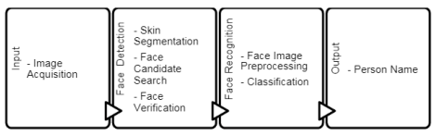

Fig 4.6 Approach to Face Recognition

**4.7 Software Design**

Many works related to Radio Frequency Identification (RFID) based Attendance Systems exist in the literature. In RFID based system, students carry a RFID tag type ID card and they need to place that on the card reader to record their attendance. RS232 is used to connect the system to the computer and save the recorded attendance from the database. This system may give rise to the problem of fraudulent access. Unauthorized person may make use of authorized ID card and enter the organization. Fingerprint based Attendance System has a portable fingerprint device which can be passed among the students to place their finger on the sensor during the lecture time without the instructor’s intervention. This system guarantees a fool-proof method for marking the attendance. The problem with this approach is that passing of the device during the lecture time may distract the attention of the students. Face detection is a basic technology of human-computer interaction. It can get information from the faces in pictures or video. Face recognition technology analyses the face image to extract the facial feature, and then identify specific target. The development of deep learning technology further improves the accuracy of face recognition. Deep Learning CNNs (Convolutional Neural Networks) have made significant breakthrough in image classification. The deep learning model DeepID developed by the Computer Vision Research Group, have achieved a recognition rate of 99.15% on LFW database, which is higher than that of human eye with 97.52%

A throughout survey has revealed that various methods and combination of these methods can be applied in development of a new face recognition system. Among the many possible approaches, we have decided to use a combination of knowledge-based methods for face detection part and neural network approach for face recognition part. The main reason in this selection is their smooth applicability and reliability issues.

**4.8 Experimental Design**

* ***Dataset***

The ORL Database of Faces, contains ten different images of each of 40 distinct subjects (400 different images).

* ***Software and Hardware Requirements***

Python based Computer Vision and Deep Learning libraries will be exploited for the development and experimentation of the project. Tools such as Anaconda Python, and libraries such as OpenCV, Tensorflow, and Keras will be utilized for this process. Training will be conducted on NVIDIA GPUs for training the end-to-end version of CNN based object detection model

**4.9 Implementation**

The attendance system based on face detection algorithm and face recognition algorithm includes following modules

(1) Record a video to ensure that every student is appeared in the video.

(2) Separate a frame per minute for class attendance.

(3) Apply deep learning algorithm CNN for face detection module. Detect all students’ faces and output coordinates.

(4) Apply deep learning face recognition algorithm for face recognition.

(5) Automatic attendance analysis module.

The seats of students are fixed so do not contrast their faces’ coordinate and determine the identity of each student to achieve automatic attendance.

The problem of automatic face recognition involves three key steps:

(1) Face Detection

(2) Feature extraction

(3) Recognition

Chapter-5

**RESULT AND DISCUSSION**

**5.1 Result**

Result In this proposed approach, face recognition student attendance system with user friendly interface is designed by using MATLAB GUI(Graphic User Interface). A few buttons are designed in the interface, each provides specific function, for example, start button is to initialize the camera and to perform face recognition automatically according to the face detected, register button allows enrolment or registrations of students and update button is to train the latest images that have been registered in the database. Lastly, browse button and recognize button is to browse facial images from selected database and recognized the selected image to test the functionality of the system respectively. In this part, enhanced LBP with radius two is chosen and used as proposed algorithm. The analysis of choosing the radius size will be further explained in the discussion.

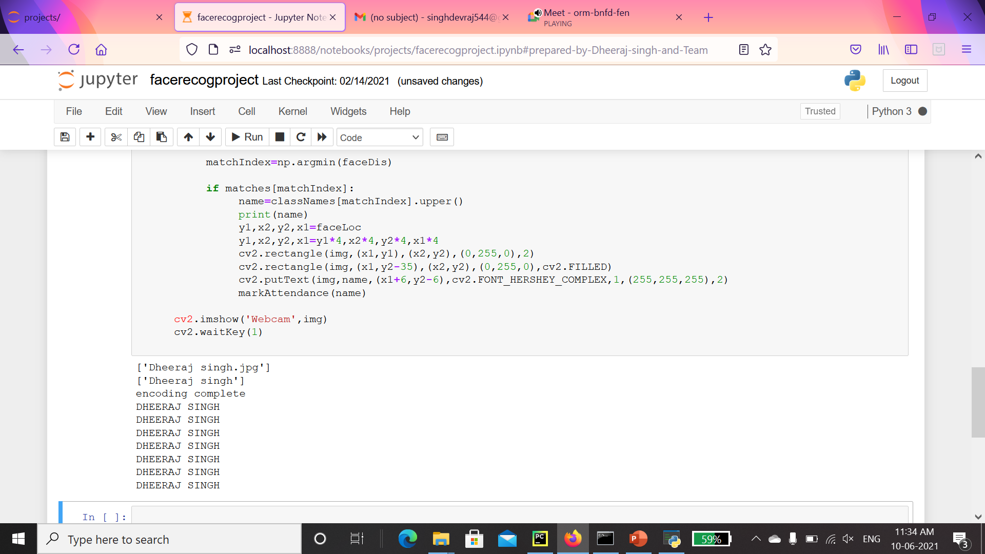

Fig 5.1 Processing image and matching with the provided dataset

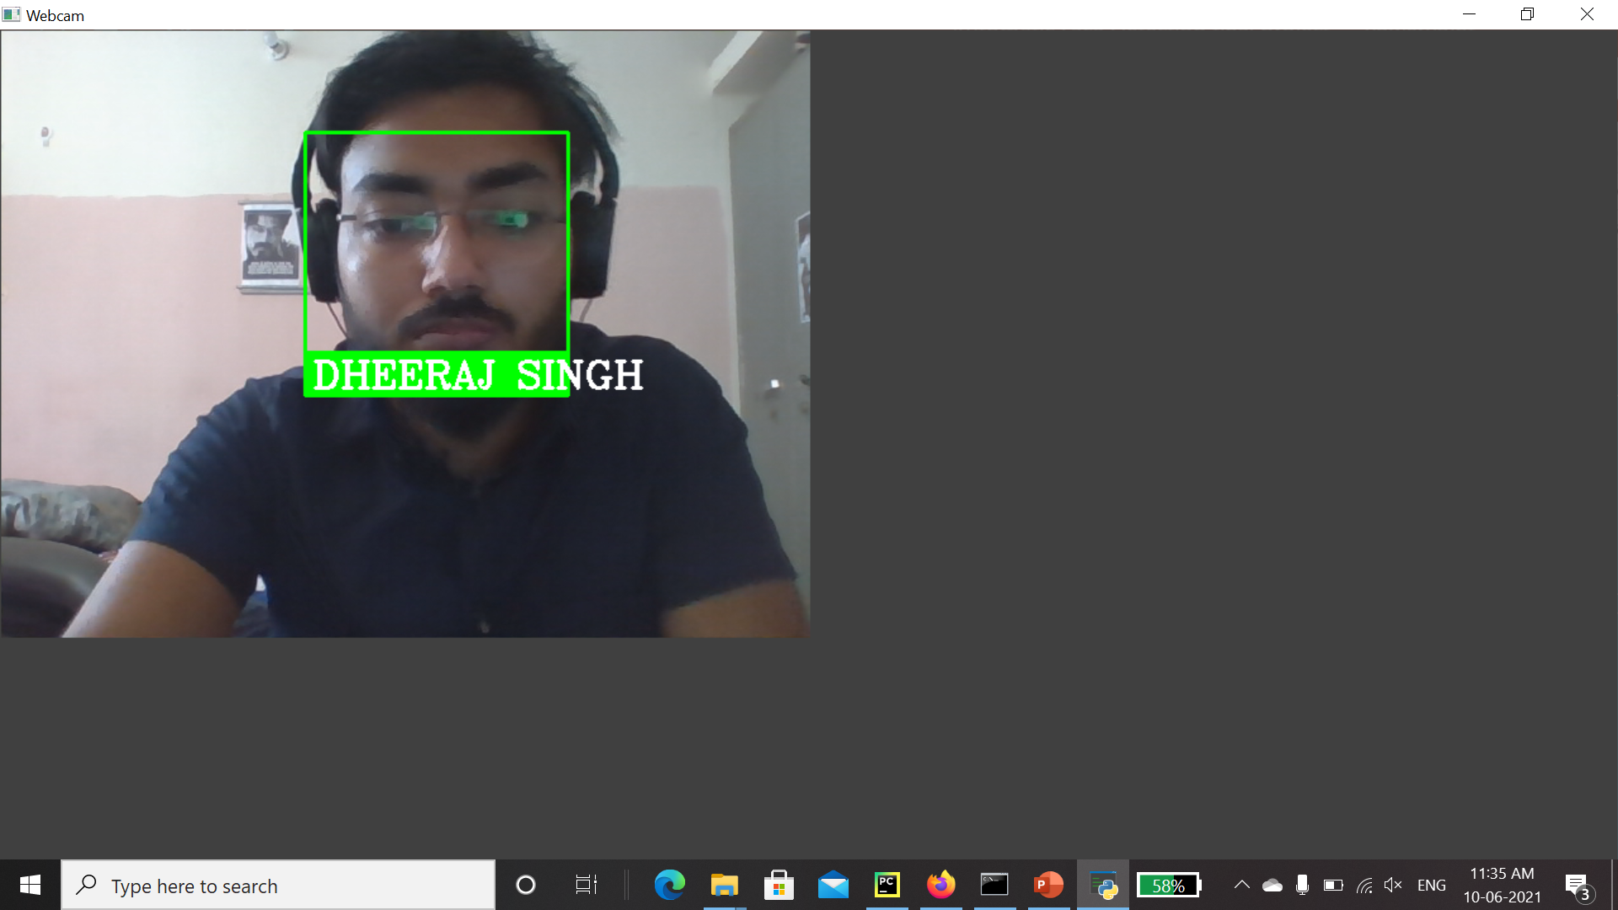

Fig 5.2 A web cam pop up when the program is run on server to detect the face in front of it and match it with the saved data set and mark the attendance of the person.



Fig 5.3 The front end of the server program



Fig 5.4 Attendance in Excel File with name and time

**5.2 Conclusion**

This proposed approach provides a method to perform face recognition for student attendance system, which is based on the texture based features of facial images. Face recognition is the identification of an individual by comparing his/her real-time captured image with stored images in database of that person. Thus, training set has to be chosen based on the latest appearance of an individual other than taking important factor for instance illumination into consideration.

The proposed approach is being trained and tested on different datasets. Yale face database which consists of one hundred and sixty-five images of fifteen individuals with multiple conditions is implemented. However, this database consists of only grayscale images. Hence, our own database with color images which is further categorized into high quality set and the low quality set, as images are different in their quality: some images are blurred while some are clearer. The statistics of each data set have been discussed in the earlier chapter.

Viola-Jones object detection framework is applied in this approach to detect and localize the face given a facial image or provided a video frame. From the detected face, an algorithm that can extract the important features to perform face recognition is designed. Some pre-processing steps are performed on the input facial image before the features are extracted. Median filtering is used because it is able to preserve the edges of the image while removing the image noises. The facial image will be scaled to a suitable size for standardizing purpose and converted to grayscale image if it is not a grayscale image because CLAHE and LBP operator work on a grayscale image.

One of the factors that are usually a stumbling stone for face recognition performance is uneven lighting condition. Hence, many alternatives have been conducted in this proposed approach in order to reduce the non-uniform lighting condition.Before feature extraction takes place, pre-processing is performed on the cropped face image (ROI) to reduce the illumination problem.

**5.3 Weakness of the Algorithm**

The proposed algorithm can only work with a single face. Multiple faces appear in the same image causes each of them to be small. Small face region gives inaccurate features, this will decreases the performance of the system. Hence,whenever more than a face is detected, the system will not perform the recognition. The LBP algorithm is highly sensitive to image quality and higly affected by the blurred image. LBP is the texture based descriptor which extracts the local grayscale features by performing feature extraction on a small region throughout the entire image. Hence, test image and train image have to be the same quality and captured by the same device in order to have high accuracy.

The laptop built in webcam is the default device in this proposed approach to capture image. The webcam and lighting source of the laptop have low performance which cause the captured images appear to be darker and blurred. This cause the system only function the best if the test image and train image are both captured at the same place under approximately same illumination.

Besides, false recognition occurs when the facial image is blurred. The blurred image caused by the after image created by movement will degrade the performance. The face feature extracted from the blurred image would be totally different compared to train image resulting in false recognition.

In addition, if an individual wears make up in the image for face recognition, the important features will be covered. Similarly, face region should not be covered by hair, beard or any accessories to ensure better performance. For instance, a girl provides a facial image with her face covered by hair, it causes false recognition to occur if the girl ties her hair. This is because anything covering the face region will be assumed as face feature. This causes a relatively large difference between test image and train image.

Different level of brightness or lighting could be a challenging problem for face recognition. Hence, limitation of the proposed algorithm is studied and analysis is conducted by modifying the pixels of high quality images in order to manipulate the brightness of the facial images. The recognition rate of facial images under different level of brightness is computed and tabulated.

The proposed algorithm function the best when the intensity increase by a constant at the range of 25 and 50.Further increasing or decreasing the intensity level out of this range will cause the recognition rate to drop to (94.12 %) .Hence, it can be said that the system work better in a relatively brighter image then a darker image.

**5.4 Recommendation**

In this proposed approach,there are a few limitations. First,the input image has to be frontal and a upright single facial image. Second,the accuracy might drop under extreme illumination problem. Third,false recognition might occur if the captured image is blurred. Besides, LBP is textural based descriptor which extracts local features. Hence, test image and train image have to be the same quality which is captured by using the same device in order to have high accuracy. Lastly, if an individual wears make up in the image for face recognition, the important features will be covered.

In fact, a better camera with a better lighting source able to reduce the illumination problem and also able to avoid the captured of blurred images. In this proposed approach, laptop built in camera is a default device. However the lighting source of the laptop camera is very dim, this cause the system to be unstable. For future work, a better camera and a better lighting source can be used in order to obtain better result. This can reduce the dependency on the brightness of environment, especially the places to capture test and train images. Furthermore, a face recognition system which has more faces other than a single facial image can be designed. This can increase the efficiency of the system. The test image and train image in this approach is highly related to each other and highly dependent on the image captured device. The capture device has to be the same for this approach to perform better.

Thus, other algorithms can be used instead of LBP, for example A.I (artificial intelligence) algorithm which can be implemented to perform the face recognition. CNN (Convolution Neural Network) which is a hot topic recently, is a machine deep learning algorithm which is able to perform recognition with less dependency on a particular train image given a large database. However, CNN requires an extremely large database to increase its accuracy or having relatively small class size to have high performance.

In pre-processing stage, an algorithm, for instance affine transform can be applied to align the facial image based on coordinates in the middle of the eyes. This might help, especially in PCA algorithm, which it maps test image to train image to perform face recognition.

Chapter-6

**CONCLUSION AND FUTURE SCOPE**

**6.1 Conclusion**

Face recognition systems are part of facial image processing applications and their significance as a research area are increasing recently. Implementations of system are crime prevention, video surveillance, person verification, and similar security activities. The goal is reached by face detection and recognition methods. Knowledge-Based face detection methods are used to find, locate and extract faces in acquired images. Implemented methods are skin color and facial features. Neural network is used for face recognition. RGB color space is used to specify skin color values, and segmentation decreases searching time of face images. FFNN is performed to classify to solve pattern recognition problem since face recognition is a kind of pattern recognition. Classification result is accurate. Classification is also flexible and correct when extracted face image is small oriented, closed eye, and small smiled. Proposed algorithm is capable of detect multiple faces, and performance of system has acceptable good results.

**6.1 Future scope**

The system we have developed has successfully, able to accomplish the task of marking the attendance in the classroom automatically and output is obtained in an excel sheet as desired in real-time. However, in order to develop a dedicated system which can be implemented in an educational institution, a very efficient algorithm which is insensitive to the lighting conditions of the classroom has to be developed. Also a camera of the optimum resolution has to be utilized in the system. Another important aspect where we can work towards is creating an online database of the attendance and automatic updating of the attendance into it keeping in mind the growing popularity of Internet of Things. This can be done by creating a standalone module which can be installed in the classroom having access to internet, preferably a wireless system. These developments can greatly improve the applications of the project

**REFERENCES**

[1] Kar, Nirmalya, et al. "Study of implementing automated attendance system using face recognition technique." International Journal of computer and communication engineering 1.2 (2012): 100.

[2] RoshanTharanga, J. G., et al. "Smart attendance using real time face recognition (smart-fr)." Department of Electronic and Computer Engineering, Sri Lanka Institute of Information Technology (SLIIT), Malabe, Sri Lanka (2013)

[3] Selvi, K. Senthamil, P. Chitrakala, and A. Antony Jenitha. "Face recognition based attendance marking system." Corresponding Author: S. Rajkumar*, Email: rajkumarsrajkumar@ gamil. com (2014).

[4] Joseph, Jomon, and K. P. Zacharia. "Automatic attendance management system using face recognition." International Journal of Science and Research (IJSR) 2.11 (2013): 327330.

[5] Ashley DuVal. (2012).Face Recognition Software -History of Forensic Psychology. [online] Available at: http://forensicpsych.umwblogs.org/research/criminal-justice/face-recognitionsoftware/ [Accessed 12 Apr. 2018].

[6] Sidney Fussell. (2018). NEWS Facebook's New Face Recognition Features: What We Do (and Don't) Know. [online] Available at: https://gizmodo.com/facebooks-new-face-recognition-features-what-we-do-an1823359911 [Accessed 25 Mar. 2018].

[7] Robert Silk. (2017). Biometrics: Facial recognition tech coming to an airport near you: Travel Weekly. [online] Available at: http://www.travelweekly.com/Travel-News/Airline-News/Biometrics-Facialrecognition-tech-coming-airport-near-you [Accessed 25 Mar. 2018].

[8] Reichert, C. (2017). Intel demos 5G facial-recognition payment technology | ZDNet. [online] ZDNet. Available at: http://www.zdnet.com/article/intel-demos-5g-facial-recognition-paymenttechnology/ [Accessed 25 Mar. 2018].

[9] P. Arun Mozhi Devan et al., (2017). Smart Attendance System Using Face Recognition. Advances in Natural and Applied Sciences. 11(7), Pages: 139-144

[10] Rahul V. Patil and S. B.Bangar. (2017). Video Surveillance Based Attendance system. IJARCCE, 6(3), pp.708-713.